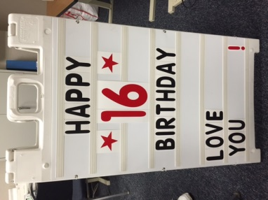

**Franklin Central PFO**

**Celebration Sign Reservation Form**

**$25 payment is due at the Main Office of the school prior to sign placement. Please address the envelope to “PFO Sign” and make checks payable to “FCHS PFO”.**

**Questions:** **Tonya Short** at [mtbd1997@comcast.net](mailto:mtbd1997@comcast.net) or **Patty Deely** at [psdeely@gmail.com](mailto:psdeely@gmail.com)

**Name_____________________________________________________**

**Address___________________________________________________**

**E-mail____________________________________________________**

**Phone____________________________________________________**

**Date you would like sign to be placed___________________________**

**Message on the sign:** (Maximum of 7 rows with 9 characters in each, including spaces between the words) (measurements of sign: 61”w x 94”l). **It will be placed on the sidewalk outside the main doors of the school.**

**________________________________________________________________________________________________________________________________________________________________________________________________________________________________________________________________________________________________________________________**

**Amount Enclosed_______________________________**

|  |
| --- |
| **For PFO use only**  **Amount $ ______ Cash______ Check______ Date Received ______** |